How to connect windows server from mac

**www.zippyops.com**

No. 209/210, 1st floor, J.Nager, Panaiyur kuppam main RD, Panaiyur ,  
Chennai 600097

**🖂**[**zippyops@gmail.com**](mailto:zippyops@gmail.com)

**✆+91 7010585768**

Setting up a remote desktop connection for Mac is easy to do. Windows machines use a different protocol, one aptly named RDP (Remote Desktop Protocol), to manage connections between Windows servers and end-user devices. We will explore using the Microsoft remote desktop setup for Mac to connect to a Windows server

Step 1: Locate Microsoft Remote Desktop

To download Microsoft Remote Desktop, open the App Store within your Applications folder by searching for the program. You can also do this by opening the Launchpad if it is not already one of the apps in your Dock.

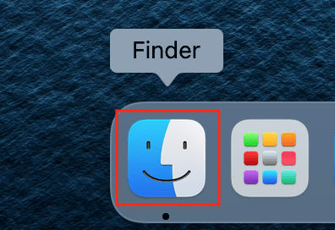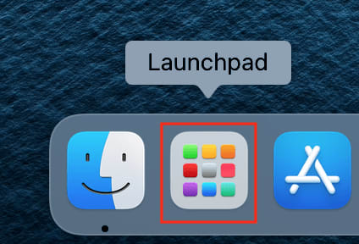

Step 2: Install Microsoft Remote Desktop

After locating the Microsoft Remote Desktop app, click Get. The icon will change to say Install, and the button will turn green. Click Install.

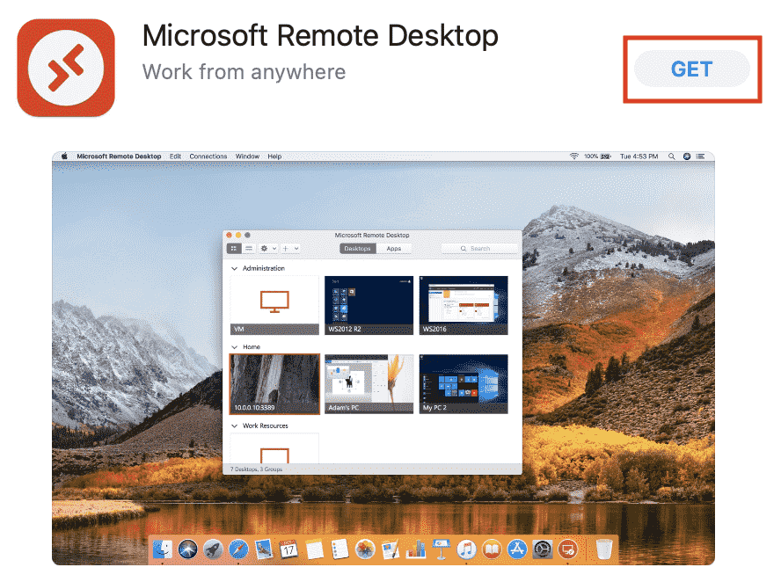

Step 3: Open the App

Once installed, launch the app by clicking on the Microsoft Remote Desktop icon in your Applications folder or activate from within the Launchpad.

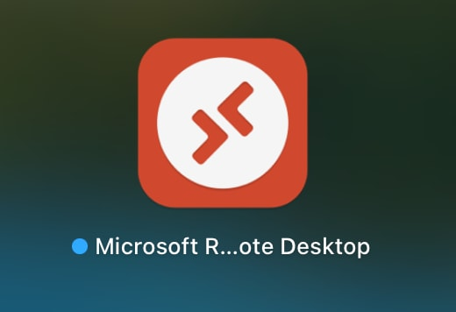

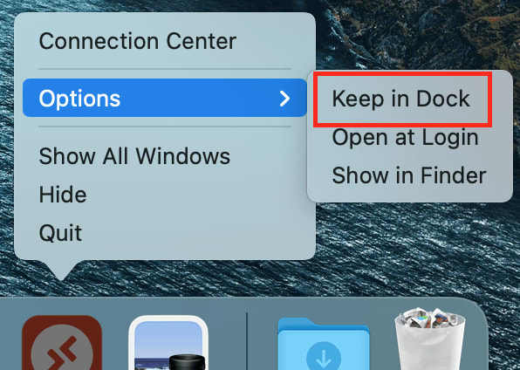

Step 4: Set Up Your Microsoft Remote Desktop Connection

With the program opened, you will either click + at the topor Add PC in the middle of the window to add a new connection.

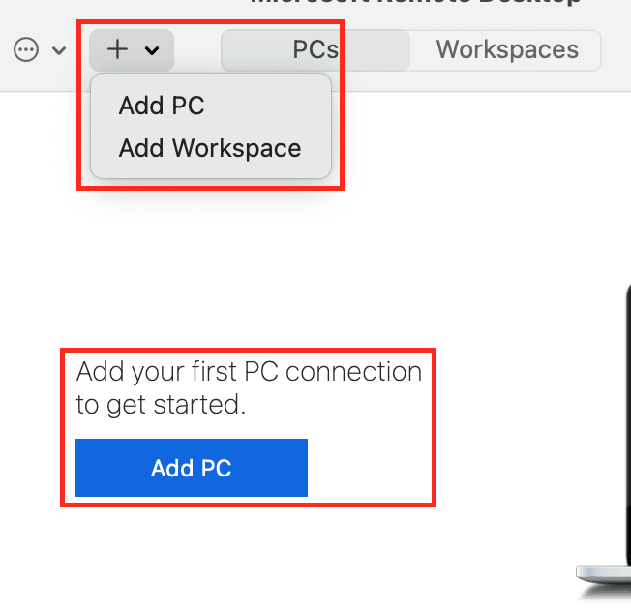

Fill out the highlighted boxes for the Windows server.

* PC Name: Enter the Windows server’s IP address.
* User Account: Click the dropdown menu and select Add User Account.

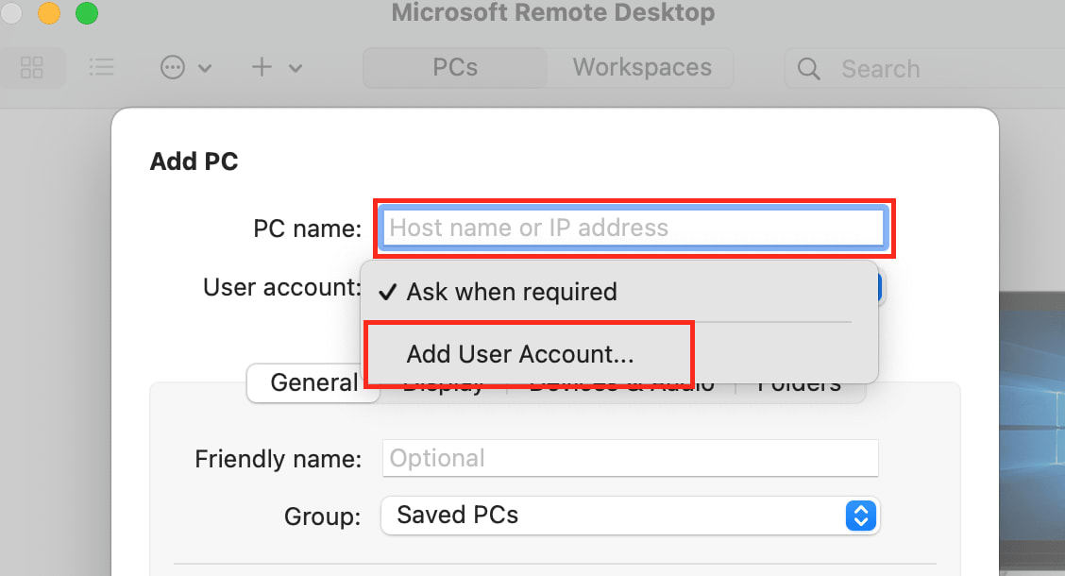

* User Name: Input your username for the target PC. For this example, we used root.
* Password: Input your password for the target PC.
* Friendly name (Optional): Here, you can choose to enter a name for your User Account. For this example, we have left this field blank. Click Add once completed.

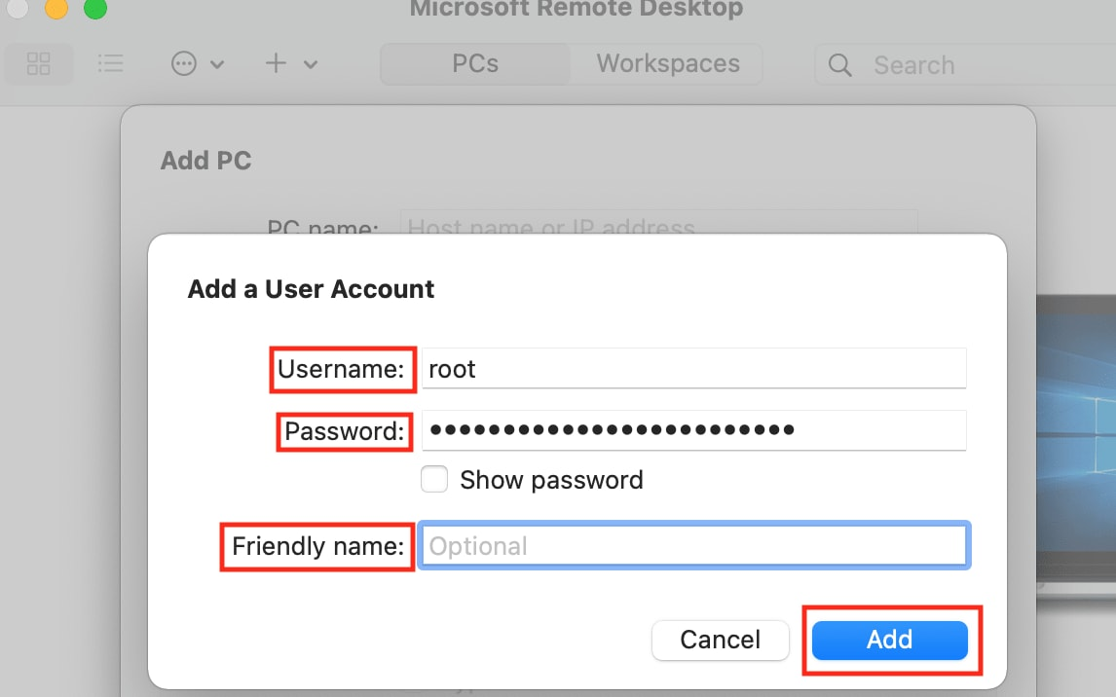

* Group: The default will be Saved PCs. You can click the dropdown menu and add a custom Group Name if you would like.
* Gateway: If a VPN or other connection is necessary for accessing the server, you can click the dropdown menu and add it here. Otherwise, leave the default of No gateway, as in this example.

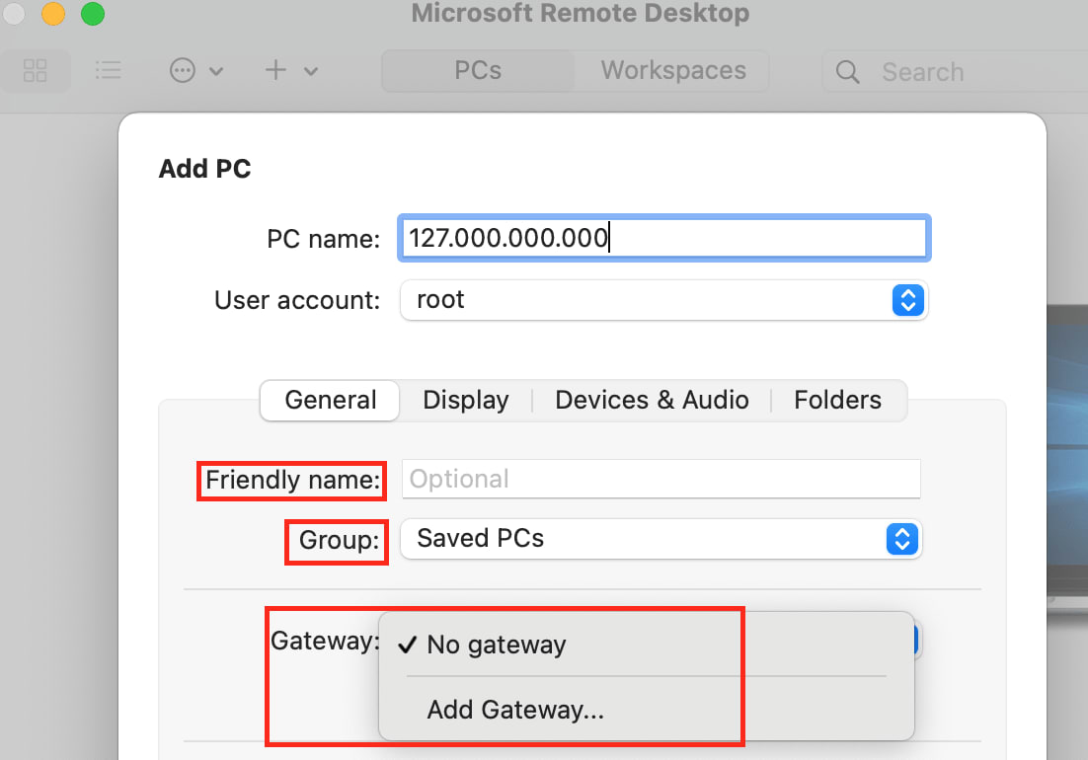

Once completed, click Add.

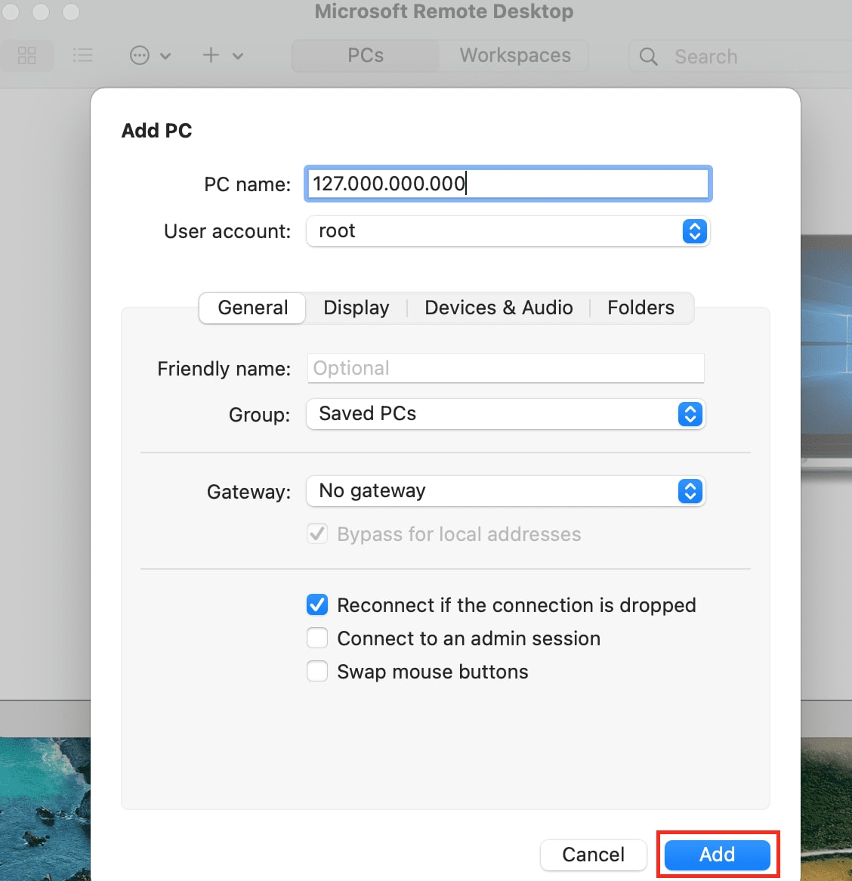

Your new server will show up as an icon in your PCs list.

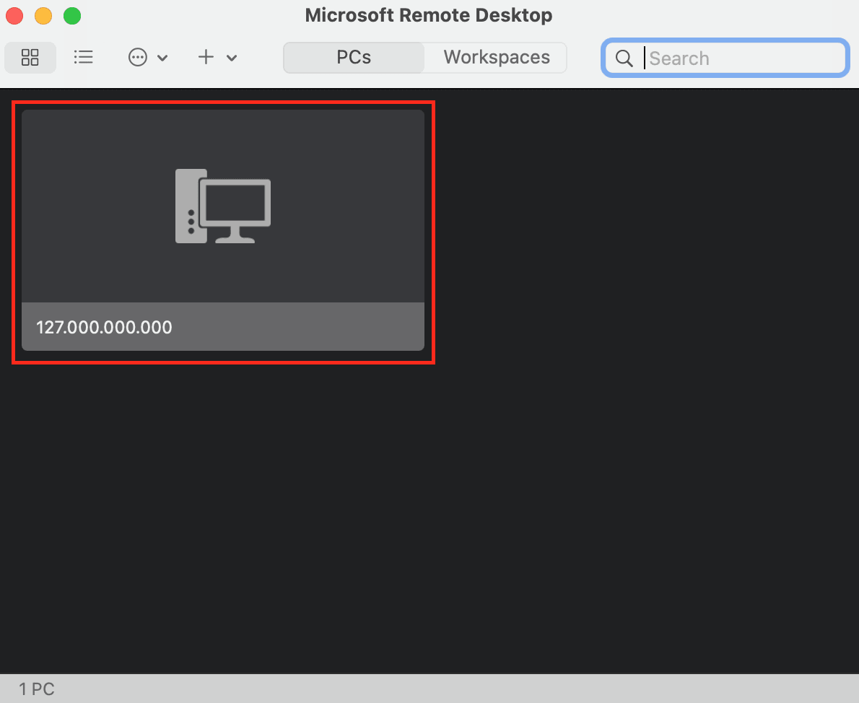

Step 5: Open Your Windows Environment

Double click on the icon for your server to connect to your Windows environment. If you entered the information correctly, the Windows environment would appear.

